Working with Multiples
Name: JASVEENA
Student ID: 224001588
Date: 01-06-2024

Learning Journey and Evidence

Review array, array index, and loops & arrays.
What did you think while reviewing this in the Programmer’s Guide? Which aspects did you already know, which were challenging? Which explanations helped, which were confusing? Etc.

What other resources did you use to help understand these concepts? Any good resources you would recommend to others?
ARRAY: A kind of variable that is used to store multiple values. The individual values in the array are called elements. We declare an array using square brackets ([]), inside which we specify the size of the array. This will give us elements that can be accessed via an index, starting at index 0. As a result, when we declare an array with 4 elements, it will use indexes 0 to 3.
Working with an array usually involves using for loops to iterate over each element of the array, with the for loop’s control variable tracking the valid indexes.
ARRAY INDEX:

Create a small program with array – access each value directly.
Show your process for this and highlight any realisations you gain.
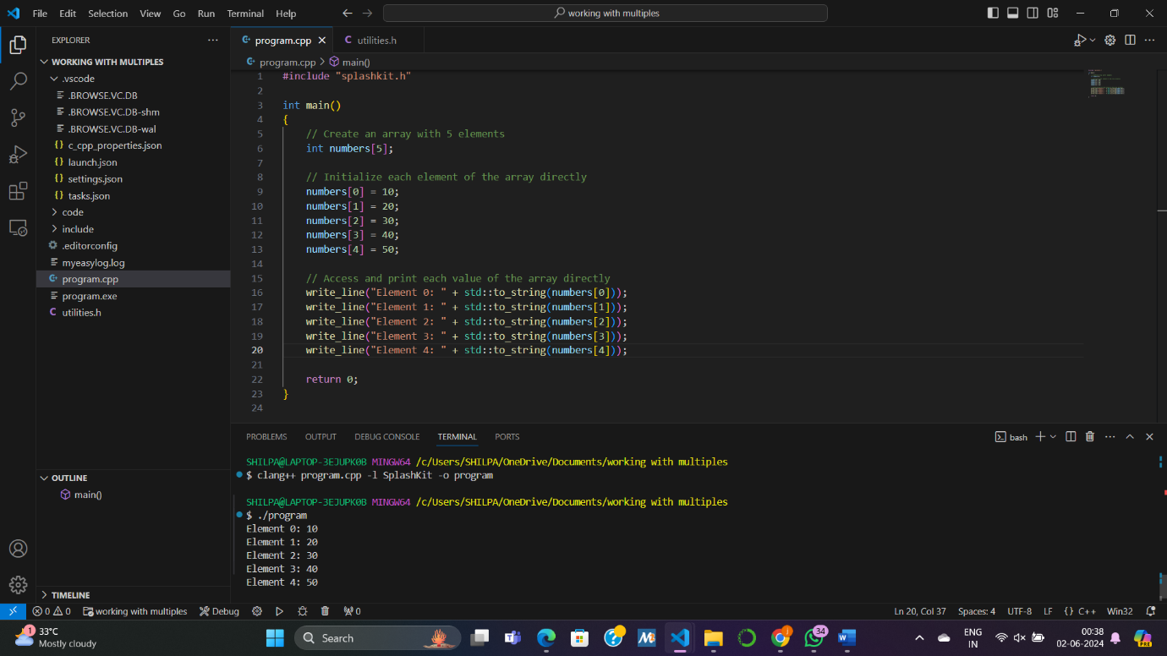

Create a small program with array – use loop to access elements.
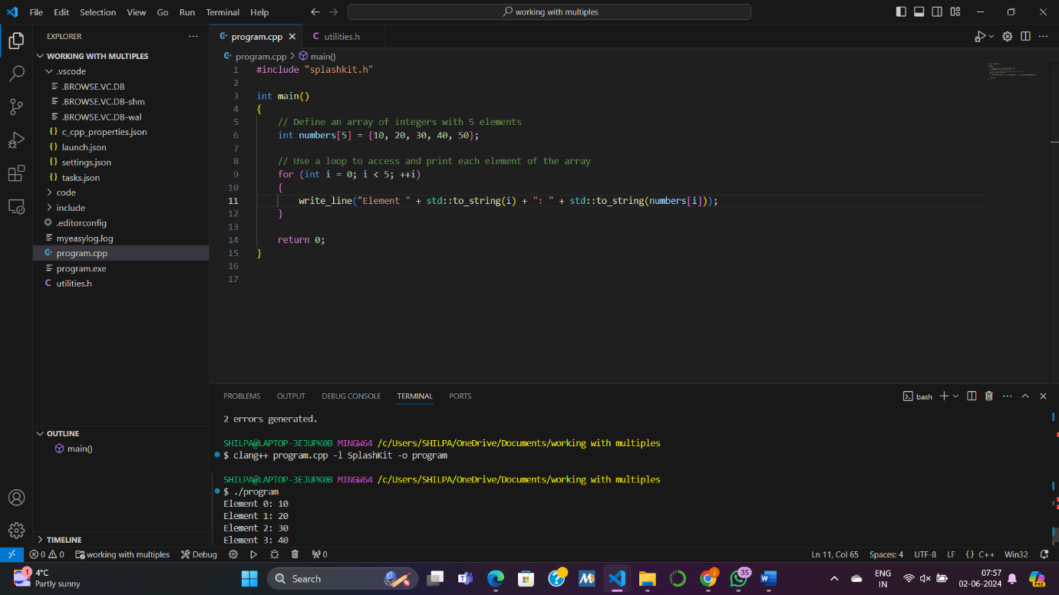

Create a small program using struct to contain array and its size.
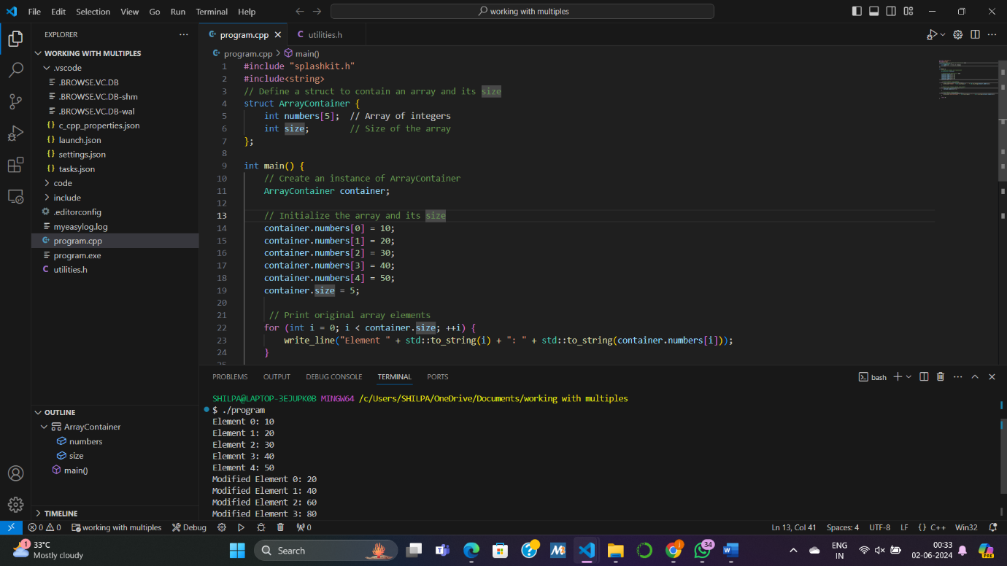

Build the Statistics Calculator program.

Create data type, read in values in populate array, output in main.
Show your process for this and highlight any realisations you gain.
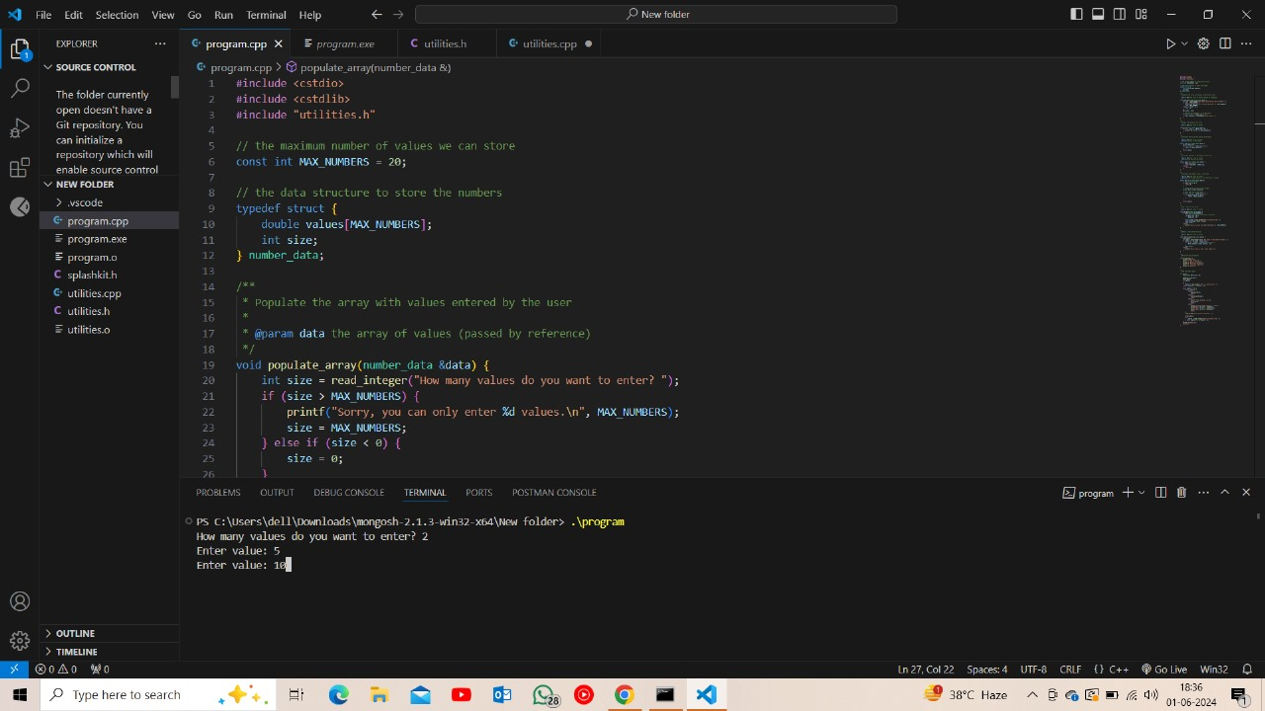

Implement Sum
Show your process for this and highlight any realisations you gain.

double sum(const number_data &data)
{
int i;
double result = 0;
for (i = 0; i < data.size; i++)
{
result += data.values[i];
}
return result;
}

In this code snippet,
Process and Realizations:
- Process: I iterated through each element of the array and added its value to the result variable.
- Realizations: I realized that summing the elements of an array is a straightforward process, but attention should be paid to handling edge cases, such as an empty array.

Implement Mean
Show your process for this and highlight any realisations you gain.

double mean(const number_data &data)
{
if (data.size > 0)
return sum(data) / data.size;
else
return 0;
}

Process and Realizations:
- Process: I divided the sum of the array elements by the number of elements to calculate the mean.
- Realizations: It's important to check for division by zero to avoid potential runtime errors.

Implement Maximum
Show your process for this and highlight any realisations you gain.

double max(const number_data &data)
{
//ensure there is data
if (data.size == 0)
return 0;
//assume the first value is the largest
double result = data.values[0];

//check the rest of the values
for (int i = 1; i < data.size; i++)
{
if (data.values[i] > result)
{
result = data.values[i];
}
}
return result;
}

Process and Realizations:
- Process: I initialized result with the first element of the array and then iterated through the rest of the elements to find the maximum value.
- Realizations: It's important to initialize result with a value from the array before comparing other values to it.

Show hand execution of your maximum function with data [-7, -1, -10], assuming at most 4 values in your array.

Implement Add Data
Show your process for this and highlight any realisations you gain.

void add_data(number_data &data)
{
if (data.size < MAX_NUMBERS)
{
if (data.size < 0)
{
data.size = 0;
}
double value = read_double("enter a value to add: ");
data.values[data.size] = value;
data.size++;
}
else
{
printf("sorry, you can only enter %d values. \n", MAX_NUMBERS);
}
}

Show hand execution of your add_data function to add 8 to [0, 5, -2], assuming at most 4 values in your array.

Process and Realizations:
- Process: I checked if there is space in the array to add a new value. If yes, I read the value from the user and added it to the array.
- Realizations: Handling edge cases, such as array overflow, is important to prevent runtime errors.

Implement Remove Data
Show your process for this and highlight any realisations you gain.

void remove_value(number_data &data)
{
print(data);
int index = read_integer("enter the index of the value to remove:");
if (index >= 0 && index < data.size)
{
for (int i = index; i < data.size - 1; i++)
{
data.values[i] = data.values[i + 1];
}
data.size--;
}
else
{
printf("sorry, that is not a valid index. \n");
}
}

Show hand execution of your remove_data function to remove data at index 1 from [1, 2, 3], assuming at most 4 values in your array.

Removing data at index 1 from [1, 2, 3]:
- New array: [1, 3]

Show hand execution of your remove_data function to remove data at index 2 from [1, 2, 3], assuming at most 4 values in your array.

Removing data at index 2 from [1, 2, 3]:
- Output: "sorry, that is not a valid index."

Show hand execution of your remove_data function to remove data at index -1 from [1, 2, 3], assuming at most 4 values in your array.

Removing data at index -1 from [1, 2, 3]:
- Output: "sorry, that is not a valid index."

Complete one of the Test Your Knowledge activities
Show your process for this and highlight any realisations you gain.
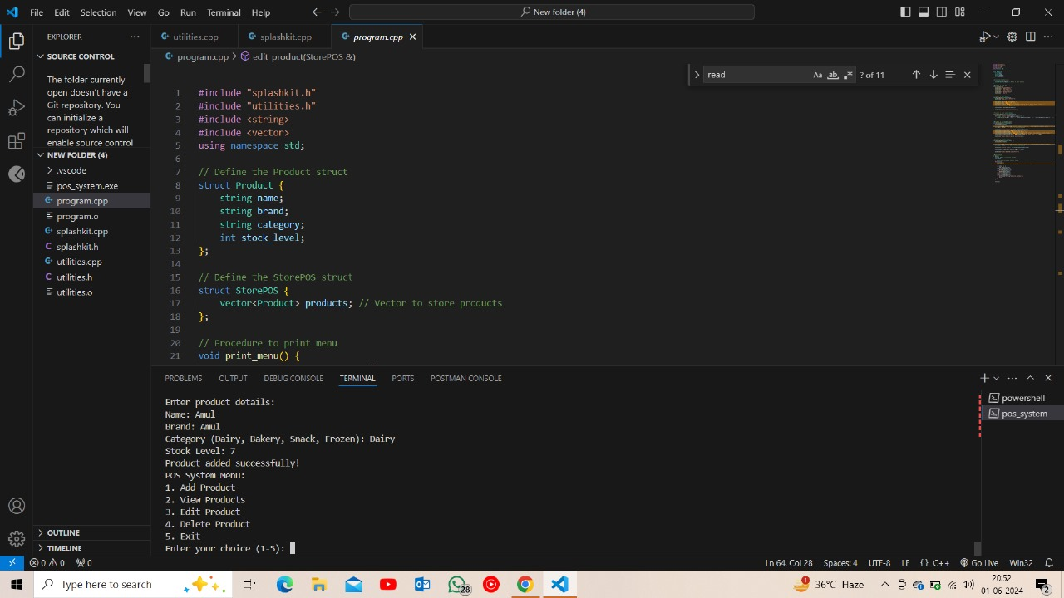

Brief Summary of Concepts
Concept | Key Idea / Concept
Array | A data structure that stores a collection of elements of the same type, accessed by index, with contiguous memory allocation.
Array Index | the position of an element within an array, typically represented by an integer value indicating its location relative to the start of the array
Array and For Loop | A programming construct where a for loop iterates over each element of an array, allowing sequential access to and manipulation of array elements.
Multi-dimensional Array | An array with more than one dimension, typically represented as a matrix or grid structure, allowing storage of data in rows and columns or higher dimensions.
Segmentation Fault | A runtime error in programming that occurs when a program tries to access memory it doesn't have permission to access, often due to dereferencing a null pointer or accessing out-of-bounds memory.
Dangling Pointers | Pointers that still hold the address of a memory location after that location has been deallocated, leading to undefined behavior when the pointer is dereferenced.

Reflection

What gives you confidence you have achieved the learning goals?

Declare and use arrays within your code in variables, fields, and parameters.
I can declare arrays within my code, whether as variables, fields, or parameters, and understand their syntax and usage

Write code that interacts with the array, and with its elements.
I am able to write code that interacts with arrays and their elements, including accessing, modifying, adding, and removing elements.

Iterate over the elements in an array to interact with each as an individual value.
I can iterate over the elements in an array using loops, such as for loops, to perform actions on each element individually.

Use hand execution to illustrate how code works with an array.
Through hand execution, I can illustrate how code interacts with arrays, demonstrating step-by-step how arrays are manipulated and how their elements are accessed and modified

What is the most important thing you learned from this and why?
The most important thing I learned from this experience is the practical application of arrays in programming. Understanding how to work with arrays effectively is crucial for many programming tasks, as arrays are fundamental data structures used in a wide range of applications. Additionally, learning to handle arrays and their elements efficiently improves code readability, performance, and maintainability. Overall, mastering arrays enhances my programming skills and enables me to tackle more complex problems in software development..

